James Collinge’s Family (Edward’s oldest brother)

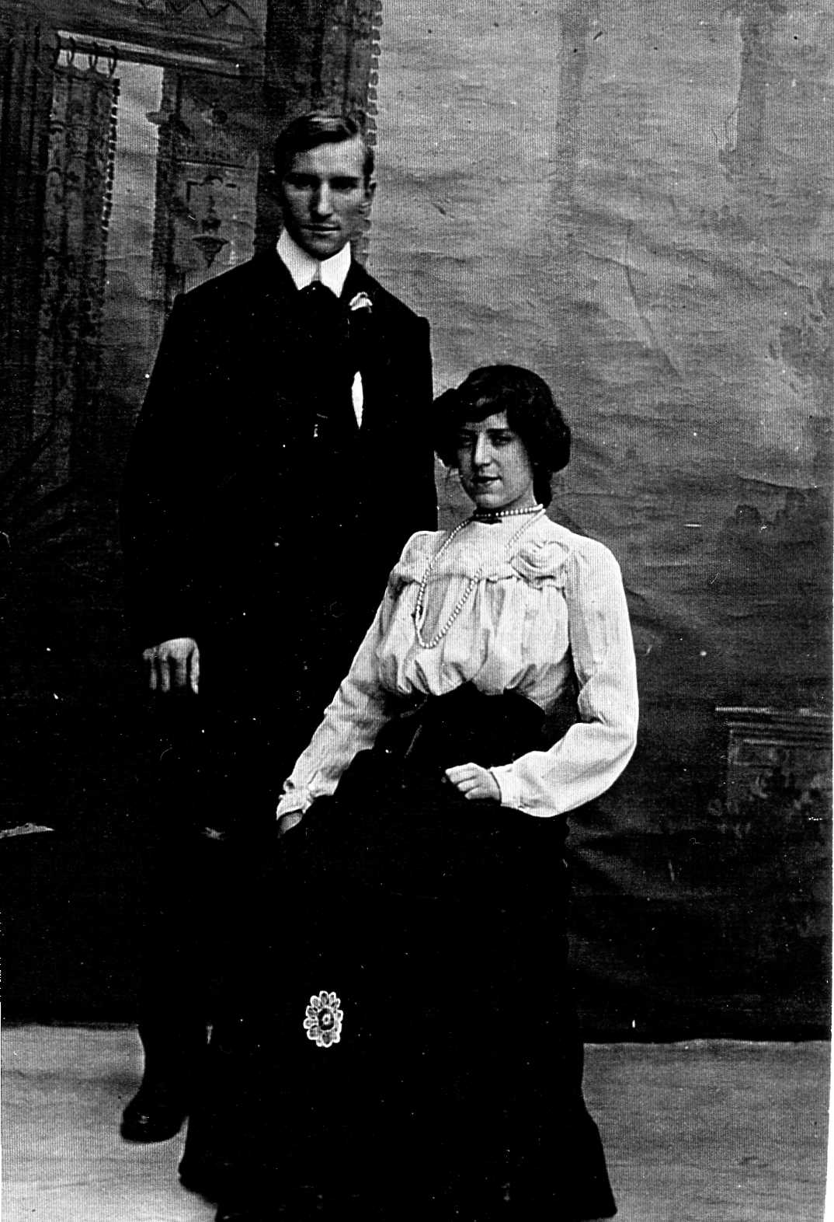

James was born on April 12, 1881 and was baptized on July 3, 1881 (Manchester, England, Births and Baptisms, 1813-1901(Cathedral). He married Edith Goodman in the last quarter (Oct, Nov, Dec) of 1906. Their son, John Birch Collinge was born on July 27, 1908 and he was baptized in the Parish Church of St. Philips Salford on September 16. They were living at 22 Stanton St. Clayton, Salford and James was an assurance agent. By the 1911 Census they were living at 40 Gully St., Nr Burghton, Manchester at which time he was a master green grower, working from their home. James died September 25 , 1960 in the Crumpsall Hospital, Manchester 8. His address at this time was 8 Scott Road, Prestwich. His estate was left to his son, John Birch (England and Wales Death Index, 1916-2007 and England and Wales National Probate Calendar).

James and Edith Collinge

This is the only photo of John Birch that is available. He is at the beach with his cousins, Jesse’s children.
Figure 1Manchester, England, Births and Baptisms, 1813-1915 for John Birch Collinge’s Baptism
John Birch married Ada W. Bowden in Q3 of 1935 and their children may have been James born in 1942, Gwen H. born in 1950 and Ian born in 1955. John died in Mar of 1992 in Salford at the age of 83. (England and Wales Death Index 1916-2007)
Jame’s Probate Record
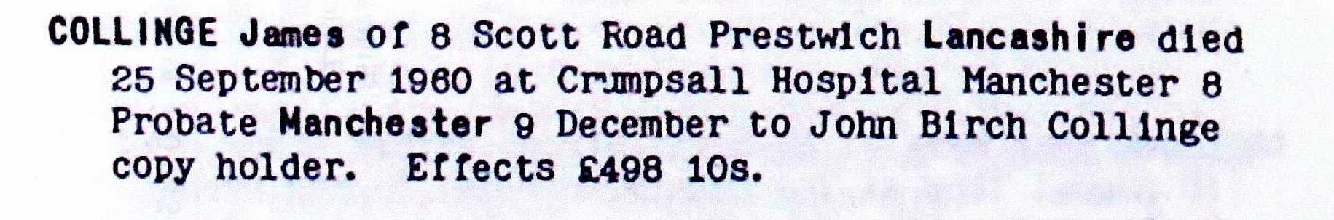
Edith Goodman (James Collinge’s wife)

Edith Goodman was born to John Kirby Goodman and Elizabeth Ann Goodman (nee Hopkinson) on December 19, 1880 and she was baptized on March 9, 1883 in St. Stephen, Salford Parish.
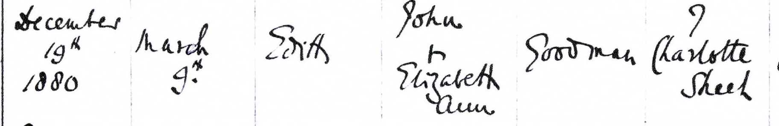
Figure 2 Manchester, England, Births and Baptisms, 1813-1915 for baptism of Edith Goodman
The family was living at 7 Charlotte St., Salford and remained there until at least the 1891 Census when Edith was 11 years old and in school. Her mother had died (no verification) and there were 2 boys and 2 girls in the family. An Irish widow was living with the family as a servant and John continued working as a policeman. By 1901 they had moved to Bury St. and Edith was working as an upholsterer. Her father had remarried Catherine Bell and had several more children. A 22- year old step-daughter was living with them. In 1906 Edith married James Colllinge.
Edith’s mother, Elizabeth Ann Hopkinson, was born in Chorlton, Lancashire to John Hopkinson and Elizabeth Wood on May 19, 1850 and she was baptized on July 14, 1850. She married John Kirby Goodman in Q2 (Apr, May, Jun) of 1872. She died after the birth of William who was 1 year old at the time of 1891 Census.

