Harry Collinge
Harry, Edward’s youngest brother, was born in Salford on Nov 16, 1888 and was baptised on Nov 30. He had a twin brother, John William, who died before the 1891 Census. The family was living at 11 West Market St. in Salford and his father, James, was a maker-up. In 1909 Harry came to Canada to farm with his eldest brother, Edward, arriving in Quebec on Oct 15. (All Canadian Passenger Lists 1865-1935)

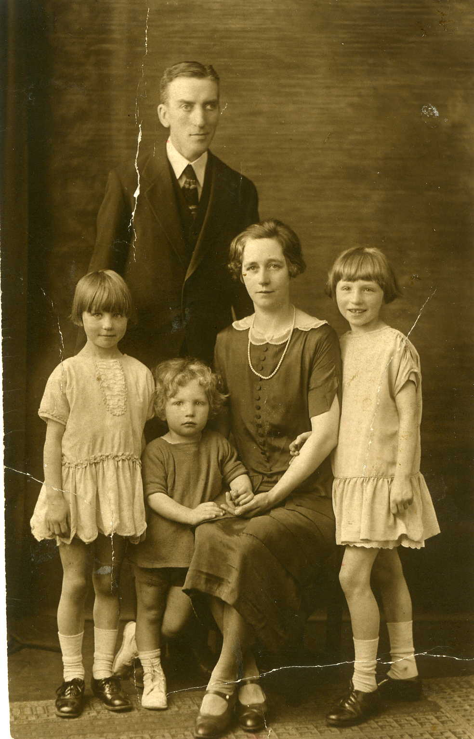
Harry and Emily
Winnifred, Geoffrey, Muriel

In Q3 of 1916 Harry married M. Emily Whitton who was born in Q2 of 1890 in Broughton, Lancashaire to John and Elizabeth Whitton. Harry and Emily had 3 children: Muriel(1918-1995), Winnifred (1921-?) and Geoffrey (1923-?). Harry was an engineer with Fords. He contracted sleeping sickness during an epidemic around 1930. He died as a result of a road accident after 1941 and Emily died in 1958.

Harry and Emily’s Children
This is Emily with their daughters, Muriel and Winnifred about 1928.

Far right Bride’s father: Harry Collinge, Groom’s family(?) Groom: Jack Mayson (1917-1944), Bride: Muriel Collinge(1918-1985), Bride’s mother: Emily Collinge, Bride’s sister: Winnifred Collinge (1919-1982) and Bride’s brother: Geoffrey Collinge (1922-2010)
Q4-1941 (Oct, Nov, Dec) Salford, Lancashire

John (Jack) Mayson, Muriel’s husband, was killed in the Battle of Britain. He is the father of Janet Susan Mayson who was born Q1-1945. They lived in Southport, Lancashire. Below is Muriel and Janet.
Muriel and Janet Winnie and Janet

Winnie, husband Lance holding niece Janet Janet with new step-sister, Jacqueline
Muriel married for the second time in 1950. Her husband was now Charles H. Marsland from Southport. They had a child, Jacqueline, who lived in California and now in Wigan, England.
Winnifred lived in Somerset with her ex-RAF husband, Lancelot F H Stevens (1917-1999). She, like Muriel, was very keen on sports. Their children all live in the south of England.
Geoffrey did engineering insurance during the war. He married Florence Joyce Marsland, and they had 2 sons, David (1960) and Richard(1962). David married Beverley Whittaker and had 3 children: Thomas(1990), Geoffrey or Gregory (1992)and Isabel(1993). David is a toxicologist and lives in the USA. Richard married Laura and they live in London. He works with computers.

Richard’s Wedding Photo (Geoffrey’ Son, Harry’s Grandson)
Beverley, David, Geoffrey, Joyce (Florence) Laura, Richard
Thomas, Geoffrey (Gregory) Isabel
This photo was given to Linda Collinge, Edward’s granddaughter, when she visited his relatives in 1996.

